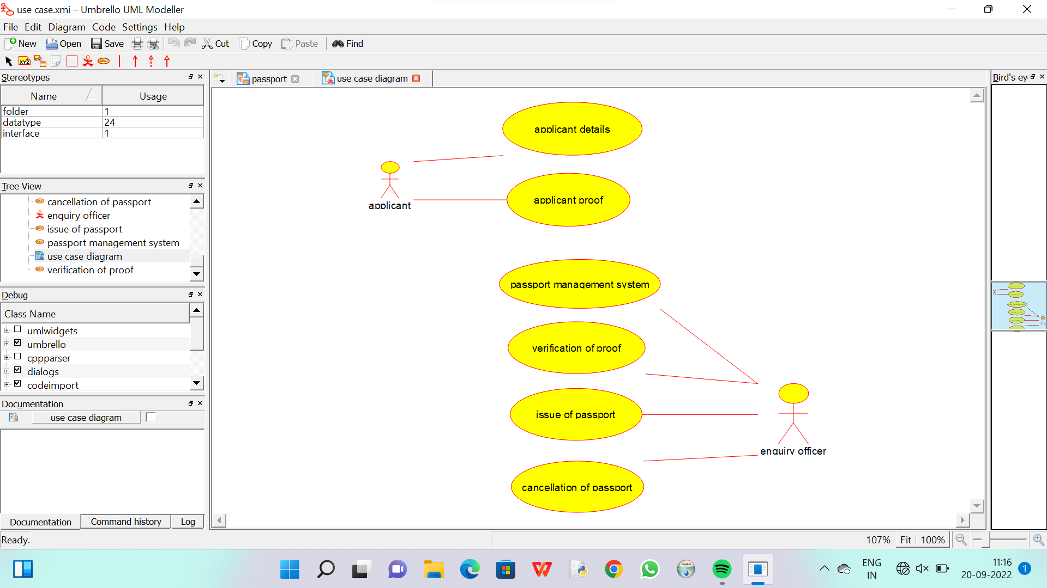

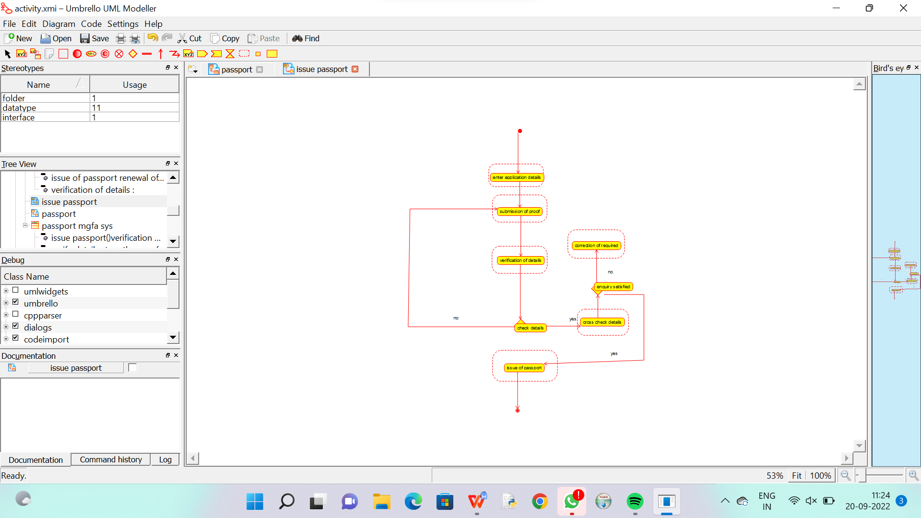

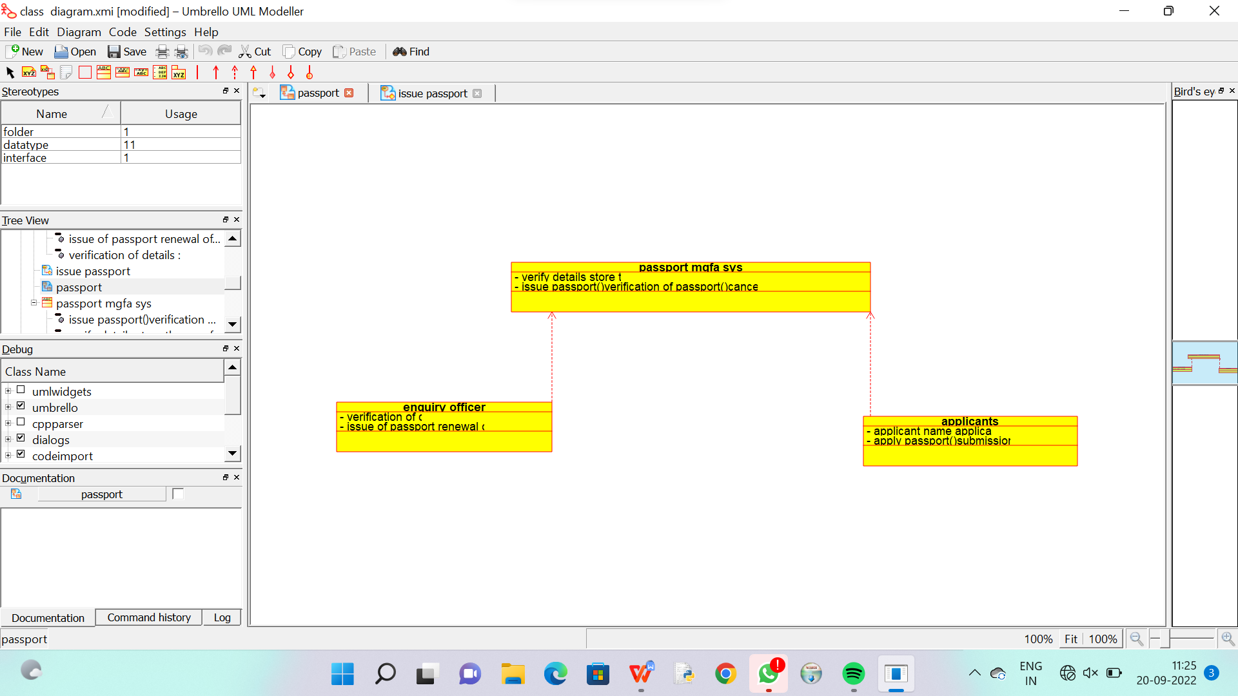

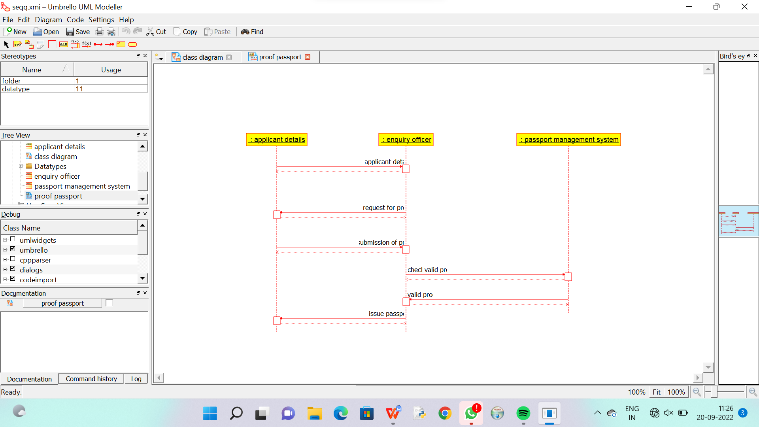

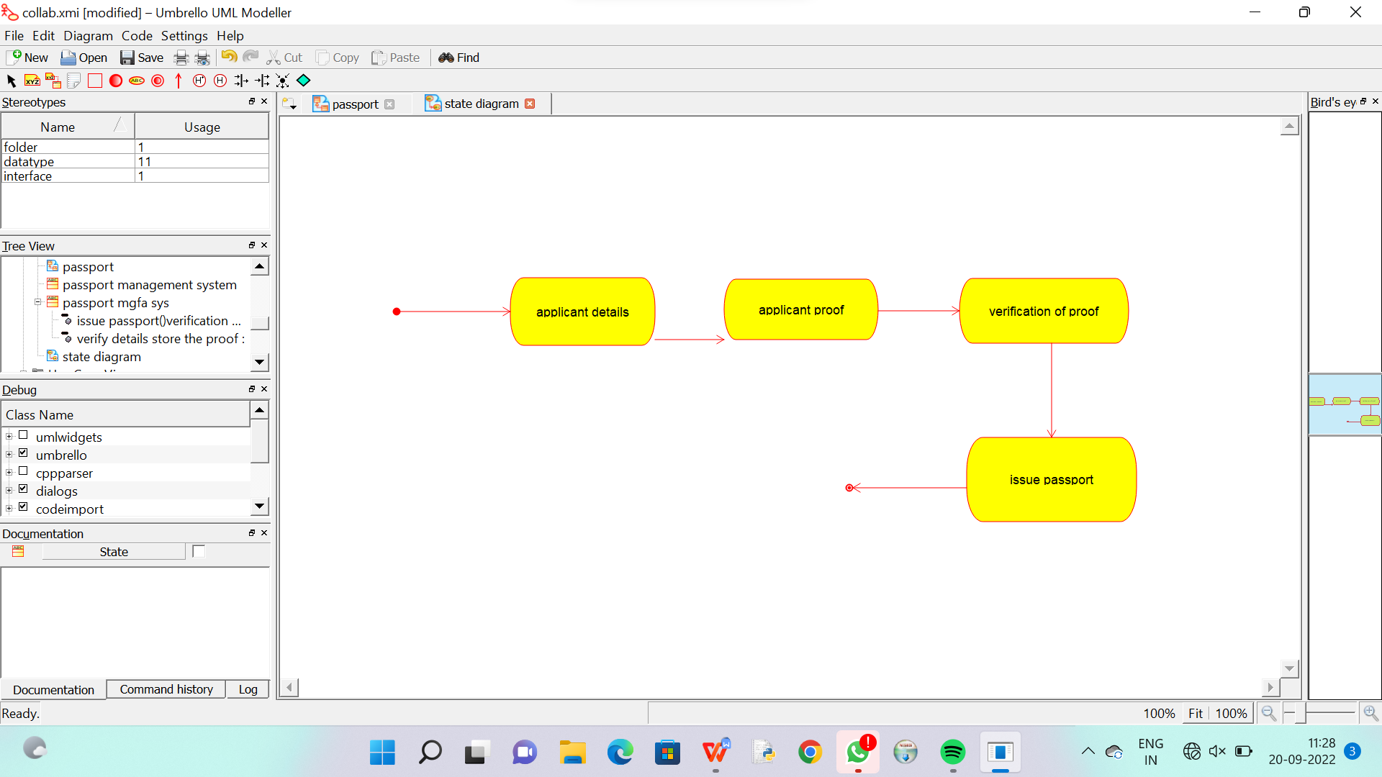

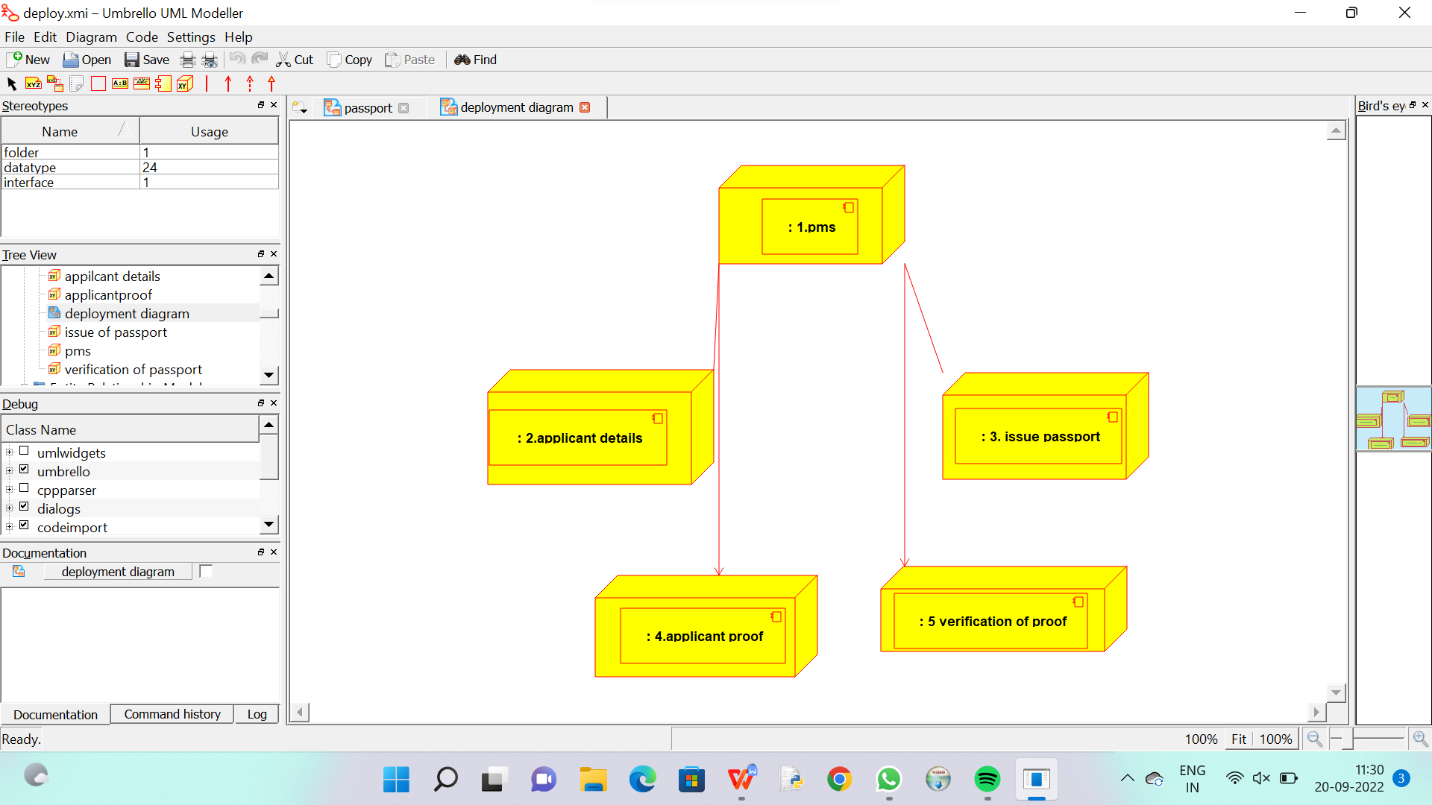

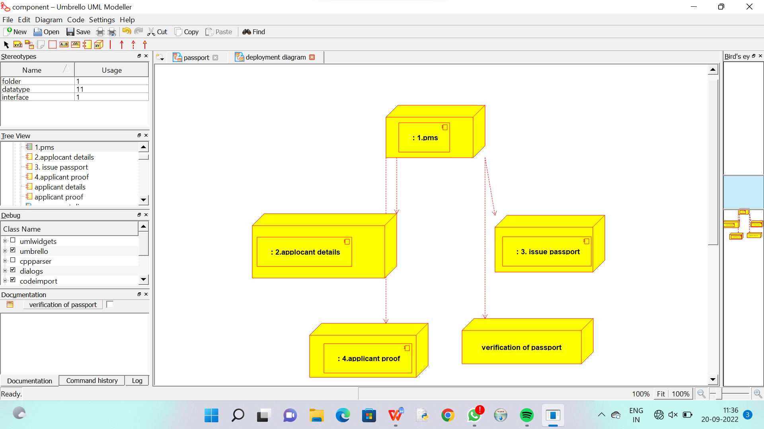

/**

 * Class passport_mgfa_sys

 */

public class passport_mgfa_sys {

  //

  // Fields

  //

  private void verify_details_store_the_proof;

  private void issue_passport_verification_of_passport_cancellation_of_passport_;

  //

  // Constructors

  //

  public passport_mgfa_sys () { };

  //

  // Methods

  //

  //

  // Accessor methods

  //

  /**

   * Set the value of verify_details_store_the_proof

   * @param newVar the new value of verify_details_store_the_proof

   */

  private void setVerify_details_store_the_proof (void newVar) {

    verify_details_store_the_proof = newVar;

  }

  /**

   * Get the value of verify_details_store_the_proof

   * @return the value of verify_details_store_the_proof

   */

  private void getVerify_details_store_the_proof () {

    return verify_details_store_the_proof;

  }

  /**

   * Set the value of

   * issue_passport_verification_of_passport_cancellation_of_passport_

   * @param newVar the new value of

   * issue_passport_verification_of_passport_cancellation_of_passport_

   */

  private void setIssue_passport_verification_of_passport_cancellation_of_passport_ (void newVar) {

    issue_passport_verification_of_passport_cancellation_of_passport_ = newVar;

  }

  /**

   * Get the value of

   * issue_passport_verification_of_passport_cancellation_of_passport_

   * @return the value of

   * issue_passport_verification_of_passport_cancellation_of_passport_

   */

  private void getIssue_passport_verification_of_passport_cancellation_of_passport_ () {

    return issue_passport_verification_of_passport_cancellation_of_passport_;

  }

  //

  // Other methods

  //

}

/**

 * Class enquiry_officer

 */

public class enquiry_officer {

  //

  // Fields

  //

  private void verification_of_details;

  private void issue_of_passport_renewal_of_passport;

  //

  // Constructors

  //

  public enquiry_officer () { };

  //

  // Methods

  //

  //

  // Accessor methods

  //

  /**

   * Set the value of verification_of_details

   * @param newVar the new value of verification_of_details

   */

  private void setVerification_of_details (void newVar) {

    verification_of_details = newVar;

  }

  /**

   * Get the value of verification_of_details

   * @return the value of verification_of_details

   */

  private void getVerification_of_details () {

    return verification_of_details;

  }

  /**

   * Set the value of issue_of_passport_renewal_of_passport

   * @param newVar the new value of issue_of_passport_renewal_of_passport

   */

  private void setIssue_of_passport_renewal_of_passport (void newVar) {

    issue_of_passport_renewal_of_passport = newVar;

  }

  /**

   * Get the value of issue_of_passport_renewal_of_passport

   * @return the value of issue_of_passport_renewal_of_passport

   */

  private void getIssue_of_passport_renewal_of_passport () {

    return issue_of_passport_renewal_of_passport;

  }

  //

  // Other methods

  //

}

/**

 * Interface applicant

 */

public interface applicant {

  //

  // Fields

  //

  //

  // Methods

  //

  //

  // Accessor methods

  //

  //

  // Other methods

  //

}